Capstone Project: Gen AI VisionOS Team Roles Contract

Language learning or historical artifacts

Meet the Team:

* Banibe Ebegbodi - Lead Developer
  + As the Lead Developer, it’s my responsibility to ensure our application is functional and its intended purpose is actualized using both generative AI methods and the VisionOS hardware. Apart from programming, I will make sure the branding of the application is consistent with the Branding Manager’s vision and will assist with the team website.
  + 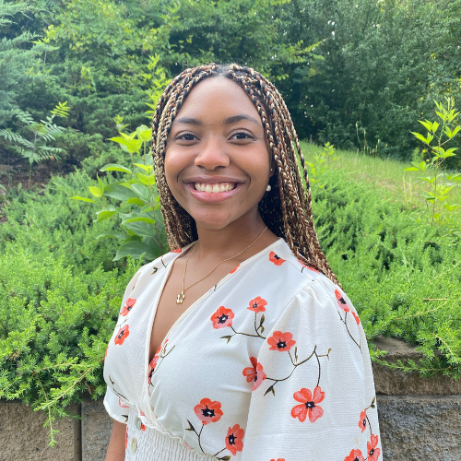
* Maggie Foster - Creative/Branding Manager
  + As the Creative and Branding Manager, it’s my responsibility to manage and develop creative assets, ensure consistent and cohesive branding, contribute to digital media strategies and content creation, and work on product development and ideation.
  + 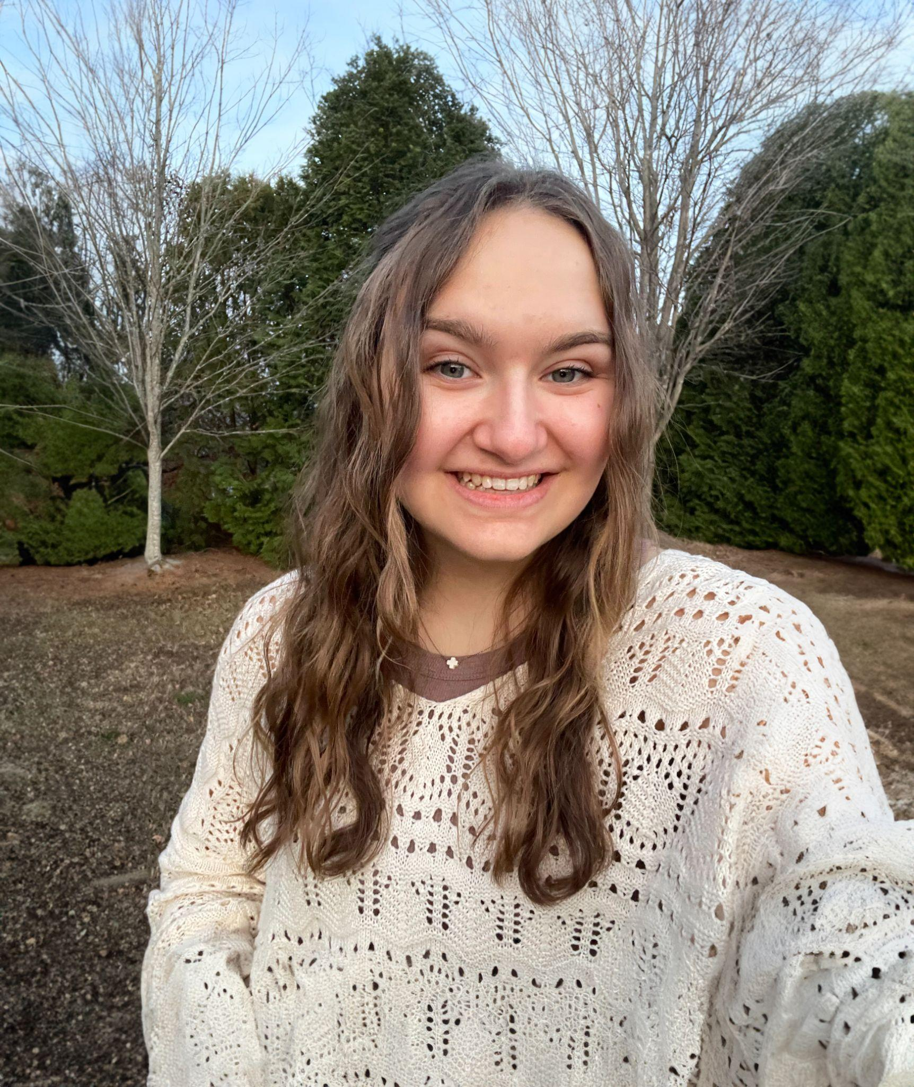
* Wesley Morgan - Project Manager
* Kati Putman - Content/PR Specialist
  + As a Content/PR Specialist, I will develop compelling written content for public release, including press materials, app descriptions, and promotional copy, while also managing internal documents to ensure clarity and alignment. My role will focus on delivering consistent messaging that represents the brand’s voice and supports our communication goals.
* Raj Sureka - Research
  + 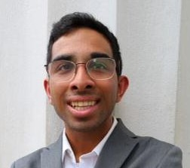
  + As the researcher, it is my responsibility to ensure that the research that is being conducted is accurate and unbiased. The findings from the research will then be used towards influencing our design and overall product decisions. After our prototyping our project, we will test our research to ensure that our final product addresses the users needs.
* **Skills and Experience**
  + As a psychology major with front-end development experience, specifically web design using HTML, CSS, php, and JavaScript which I learned from the NMI, from working on personal projects, and from previous internship experiences. From my previous experience as a UX research intern this past summer, I have chosen to take the responsibility on the research portion from this project.

Checkpoint breakdown

Checkpoint 1

* Presentation- Wesley Morgan
* Alpha - Banibe Ebegbodi
* Exploratory research- Raj Sureka
* Project plan- Maggie Foster
* pr/faq- Kati Putman

Checkpoint 2

* Presentation- Kati Putman
* User research - Raj Sureka
* Beta - Wesley Morgan, Banibe Ebegbodi
* UX Map - Maggie Foster

Checkpoint 3

* Presentation - Wesley Morgan
* 1.0 - Banibe Ebegbodi
* Visual design guide + poster - Maggie Foster
* Website beta - Raj Sureka, Banibe Ebegbodi
* SLAM Promotional material- Kati Putman

Checkpoint 4

* Stage presentation beta - Maggie Foster
* 1.1 - Banibe Ebegbodi, Raj Sureka
* launch/handoff/social deliverables- Kati Putman
* Resumes (individual)

Preface

Team Roles

Culture and FAQ

TEAM CULTURE

What is our project? Apple Vision OS App

What are our goals? Create an app that integrates GenAI with the VisionOS

How will we communicate? Slack and Zoom

What will our group culture look like? Productive, with a fun and relaxed work environment.

How will we address conflict? In person, if things get to where that is not possible, we will. bring in an instructor

What are the unknowns for this project? Most group members have never used an Apple Vision pro and don’t know the full scope of its capabilities. We are also still finalizing our development idea.

What will we adjust in the future? We may adjust team member size for each Checkpoint depending on which section may need more help.